Bellevue High School Boys’ Swim and Dive
Team Suit and Cap Order Form
Order deadline is Monday, December 4th
Swimmer’s Name ________________________________________
Phone ________________ email ____________________________

Checks payable to BHS Boys Swim and Dive Booster Club

Order:
Please order me _______ suit(s) at $40.00 each in size_________
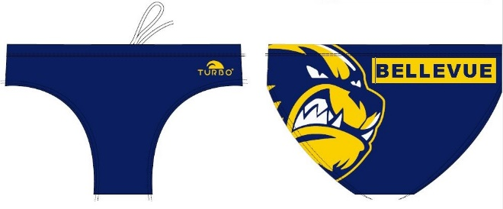

Please order me ________ Wolverine cap(s) at $10.00 ea

Total ___________

